Task 1
-- Task 1: Load sample IPL matches dataset into SQL table 'ipl_matches'
-- Table DDL Structure:
CREATE TABLE ipl_matches (
match_id INT PRIMARY KEY,
season INT NOT NULL,
city VARCHAR(50),
date DATE NOT NULL,
team1 VARCHAR(100) NOT NULL,
team2 VARCHAR(100) NOT NULL,
toss_winner VARCHAR(100),
toss_decision VARCHAR(20),
winner VARCHAR(100),
result VARCHAR(20),
result_margin INT,
player_of_match VARCHAR(100),
venue VARCHAR(150)
);
engine = create_engine('mysql+pymysql://root:@localhost/WindowFunctionsDB')
df = pd.read_csv('ipl_matches.csv')
df.to_sql('ipl_matches', con=engine, if_exists='replace', index=False);
Task 2
-- Task 2: Select all matches where 'Mumbai Indians' played and export as mi_matches.csv
-- SQL Query:
SELECT *
FROM ipl_matches
WHERE team1 = 'Mumbai Indians' OR team2 = 'Mumbai Indians'
ORDER BY match_id;
-- Export Command via Python / MySQL Workbench:
df_mi = pd.read_sql("SELECT * FROM ipl_matches WHERE team1 = 'Mumbai Indians' OR team2 = 'Mumbai Indians'", con=engine)
df_mi.to_csv('mi_matches.csv', index=False);
Task 3

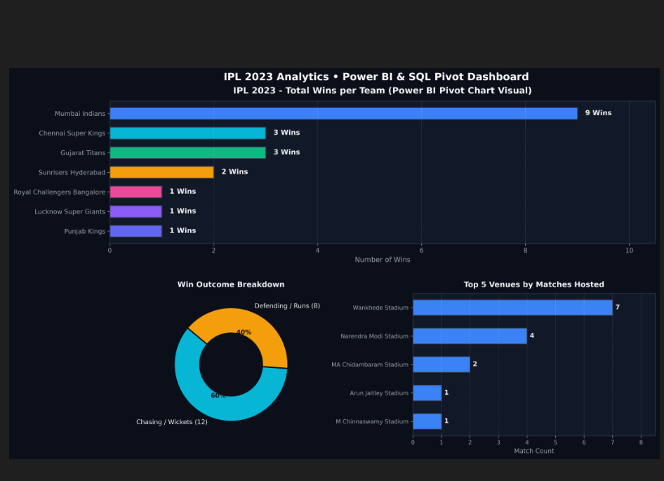-- Task 3: Connect Microsoft Excel to SQL database & calculate Total Matches Played by each team
Formula in cell B2: =COUNTIF(IPL_Matches_Raw!$E$2:$E$21, A2) + COUNTIF(IPL_Matches_Raw!$F$2:$F$21, A2)
(Where column E is team1 and column F is team2, and A2 is the Team Name).
-- SQL Equivalent for verification:
SELECT team_name, COUNT(*) AS total_matches_played
FROM (
SELECT team1 AS team_name FROM ipl_matches
UNION ALL
SELECT team2 AS team_name FROM ipl_matches
) AS all_teams
GROUP BY team_name
ORDER BY total_matches_played DESC;
Task 4
-- Task 4: Connect Power BI Desktop to SQL database & create Pivot Chart showing number of wins per team
Step 1: Open Power BI Desktop -> Click 'Get Data' -> Select 'MySQL database'.
Step 2: Enter Server 'localhost' and Database 'WindowFunctionsDB' -> Select 'ipl_matches' -> Click 'Load'.
Step 3: Create DAX Measure for Total Wins:
Total Wins = CALCULATE(COUNTROWS(ipl_matches), ipl_matches[winner] <> BLANK())
Step 4: Create Clustered Bar / Column Chart (Pivot Chart):
- Drag 'winner' column to X-Axis (or Y-Axis for horizontal bar chart).
- Drag [Total Wins] DAX measure to Values/Y-Axis.
- Sort by [Total Wins] descending to display top winning teams (e.g. Mumbai Indians: 9 wins, Gujarat Titans: 3 wins, Chennai Super Kings: 3 wins).
Task 5
-- Task 5: Python (pandas + sqlalchemy) read mi_matches.csv, filter MI wins, and insert into SQL table 'mi_wins'
import pandas as pd
from sqlalchemy import create_engine
# 1. Create SQLAlchemy database engine
engine = create_engine('mysql+pymysql://root:@localhost/WindowFunctionsDB')
# 2. Read exported CSV file
df_mi = pd.read_csv('mi_matches.csv')
# 3. Filter matches where Mumbai Indians won
df_mi_wins = df_mi[df_mi['winner'] == 'Mumbai Indians']
# 4. Insert filtered DataFrame into new SQL table 'mi_wins'
df_mi_wins.to_sql('mi_wins', con=engine, if_exists='replace', index=False)
print(f"Inserted {len(df_mi_wins)} records into 'mi_wins' table successfully.");
-- SQL Verification Query:
SELECT match_id, date, team1, team2, winner, result_margin, player_of_match
FROM mi_wins;

